Gambar 1
Model Penelitian
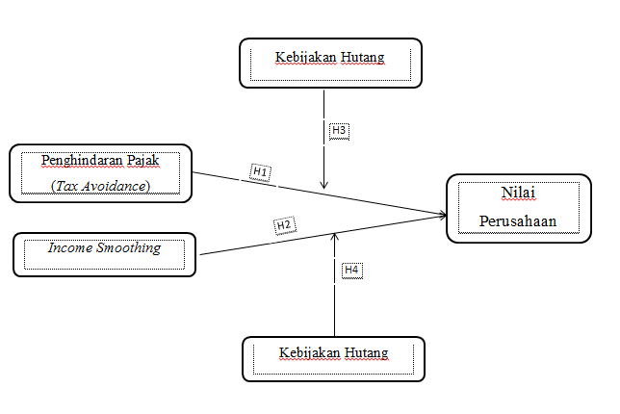

Sumber : Akbari et.,al (2018) dan Ni Wayan Saraswati,dkk (2019)

