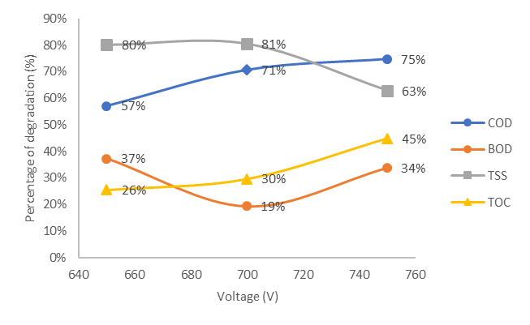
Figure . Percentage degradation of pollutant parameters in tofu wastewater that has been treated at several variations of CGDE voltage (anode depth of 2 cm, Na₂SO₄ 0.02 M, Fe²⁺ 60 mg/L ions, and temperature of 50ºC)

