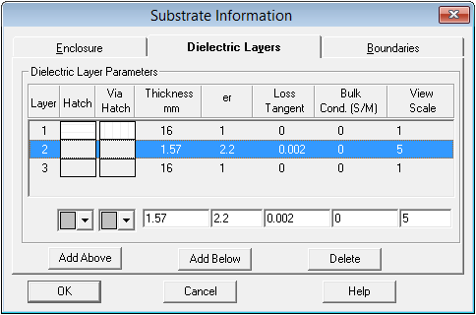

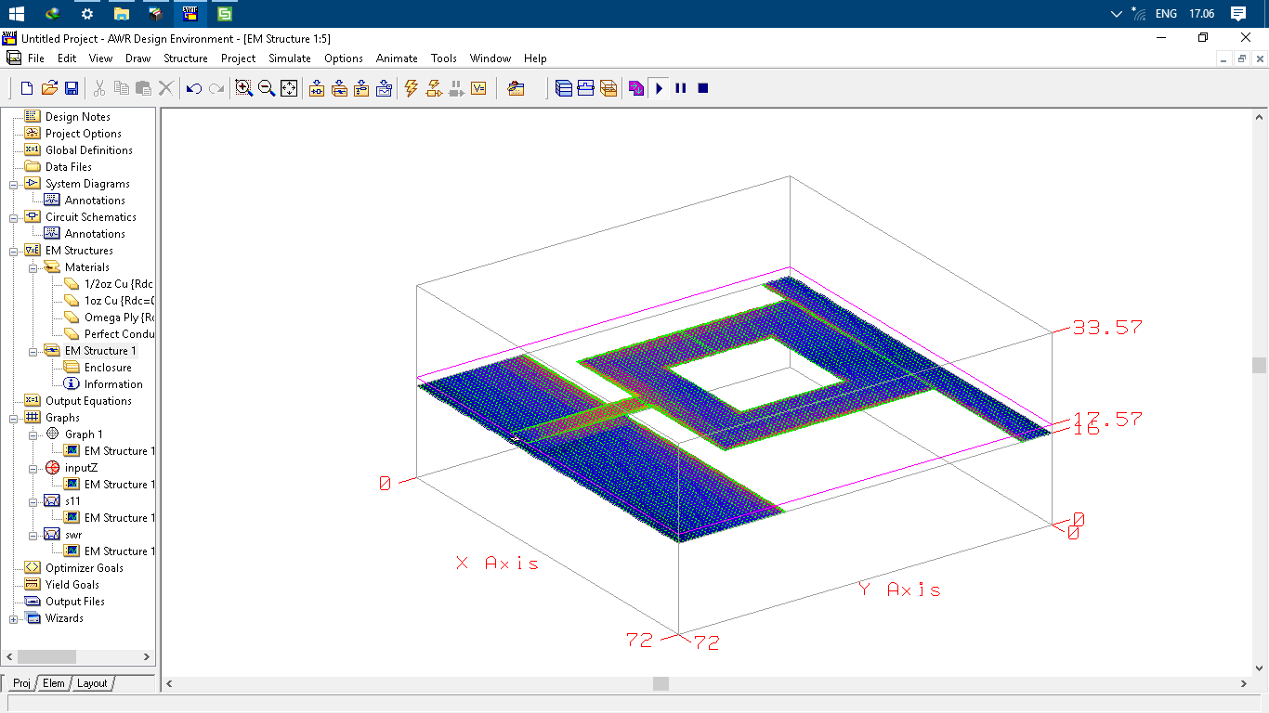

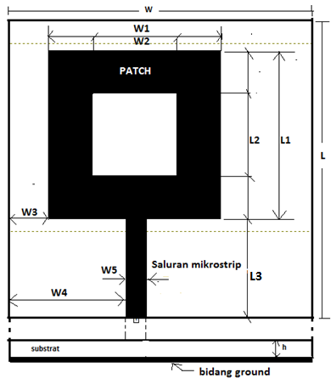

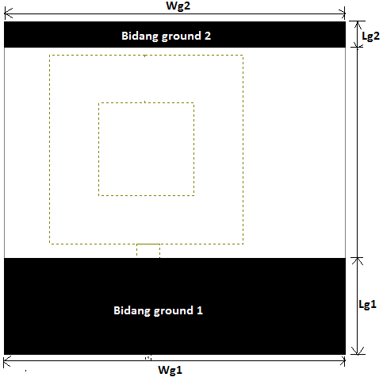

Tabel 1. rancangan tampak permukaan

|  |  |  |
| --- | --- | --- |
| Dimensi | Simbol | Ukuran |
| Luasan Substrat | W x L | 72 mm x 72 mm |
| Luasan Patch | W1 x L1 | 40,8 mm x 40,8 mm |
| Luasan Celah Patch | W2 x L2 | 20 mm x 20 mm |
| Panjang Saluran | L3 | 24 mm |
| Lebar Saluran transmisi | W5 | 4,8 mm |
| Posisi Patch | W3 | 9,6 mm |
| Posisi saluran | W4 | 28 mm |

### Tabel 2. rancangan tampak bawah

|  |  |  |
| --- | --- | --- |
| Dimensi | Simbol | Ukuran |
| Luasan Bidang ground 1 | Wg1 x Lg1 | 72mmx 20,8mm |
| Luasan Bidang ground 2 | Wg2 x Lg2 | 72mm x 5,6 mm |

