Application of Contemporary Smart Building Architecture at the Parahyangan Citywalk Shopping Center in Kota Baru Parahyangan

**Agung Prabowo Sulistiawan a, Mohd.Aflah Fernanda b, Andiyanc**

*a,bArchitectural Studies Program, Faculty of Architecture and Design, Institut Teknologi Nasional (ITENAS), Jl. PH.H. Mustapa No.23, Bandung and 40124, Indonesia*

b*Architecture Study Program, Faculty of Science and Engineering, Universitas Faletehan,Jl.Parakan Resik No.2, Bandung and 40266,Indonesia*

Corresponding author: andiyanarch@gmail.com

|  |  |  |
| --- | --- | --- |
| A R T I C L E I N F O  Article history:  Submitted 00 December 00  Received 00 December 00  Received in revised form 00 January 00  Accepted 00 February 00  Available online on 00 March 00  *Keywords:*  Shopping Center, Contemporary Architecture, Smart BuildingTechnology, Industry Revolution.  *Kata kunci:*  Pusat Perbelanjaan, Arsitektur Kontemporer, Teknologi Smart Building, Revolusi Industri. |  | A B S T R A C T |
| Under the development of an increasingly modern era, intelligent buildings and infrastructure need to be built and operated in line with the progress of the future city. Shopping center building is a building that became one of the hallmarks of the city. Therefore the application must be prominent in the surrounding building. This is the basis for taking the use of contemporary concepts. The scope of this research is on the design of Shopping Center buildings that follow modern architectural trends and the interaction of trends on public needs in the future. The purpose of this study is to design a shopping center facility that combines the concept of contemporary architecture with the idea of intelligent building as a supporting element so that the building can adapt to the times in the digitalization era of the industrial revolution 4.0. The method used in this research is descriptive qualitative by applying seven principles of contemporary architecture and the concept of intelligent building in designing supporting facilities. The result of this research is a design of a shopping center building in Kota Baru Parahyangan Bandung by applying a combination of contemporary architectural concepts and intelligent building concepts that pay attention to the orientation and aspects of the surrounding environment. The combination of this concept not only cares for its completeness but also accommodates a lifestyle so that this shopping center can attract visitors with its technological innovations and the visual appearance of elegant contemporary architecture. |
| A B S T R A K |
| Sesuai perkembangan zaman yang semakin modern, bangunan pintar dan infrastruktur perlu dibangun dan dioperasikan seiring dengan kemajuan kota masa depan.Bangunan pusat perbelanjaan merupakan bangunan yang menjadi salah satu ciri dari kemajuan suatu kota. Sebuah kota dapat dikatakan memiliki kemajuan apabila memiliki sebuah fasilitas yang baik dan lengkap. Salah satu fasilitas yang harus dimiliki suatu daerah adalah sebuah pusat perbelanjaan. Ruang lingkup penelitian ini difokuskan pada perancangan bangunan Pusat Perbelanjaan yang mengikuti tren arsitektur kontemporer dan tren interaksi kebutuhan publik di masa depan. Tujuan penelitian ini adalah mendesain sebuah fasilitas pusat perbelanjaan yang memadukan konsep arsitektur kontemporer dengan konsep smart building sebagai unsur penunjangnya agar bangunan dapat menyesuaikan dengan perkembangan zaman di era digitalisasi revolusi industry 4.0.Metode yang digunakan dalam penelitian ini adalah deskriptif kualitatif dengan menerapkan 7 prinsip arsitektur kontemporer dan konsep smart building dalam merancang fasilitas penunjang pada bangunan pusat perbelanjaan ini. Hasil penelitian ini adalah sebuah rancangan bangunan pusat perbelanjaan di Kota baru Parahyangan Bandung dengan menerapkan perpaduan konsep arsitektur kontemporer dan konsep smart building yang memperhatikan orientasi dan aspek lingkungan sekitar. Perpaduan konsep ini tidak hanya memperhatikan kelengkapan fasilitasnya saja namun dapat menampung kegiatan gaya hidup penggunanya sehingga pusat perbelanjaan ini dapat menjadi daya tarik bagi para pengunjung dengan inovasi teknologinya dan tampilan visual arsitektur kontemporer yang elegan.  Available online at <http://dx.doi.org/10.36055/teknika>. |

1. Introduction

One indicator of the progress of an area is to have a variety of excellent and complete facilities. One of the facilities that must exist is a shopping center. The shopping center is a focal point of an area, so that the building must be designed to stand out more than the surrounding buildings. In addition, the concept chosen should apply the idea of flexible and changing times. This is the basis of the idea of selected contemporary architecture. Based on the understanding of [1], applying this modern concept offers flexible use. This concept is based on quality fixed on a particular architectural grouping and combines several styles to respond to various kinds of technological developments. Shopping centers are a focal point so that the application of contemporary architectural concepts is considered very appropriate.

Based on the theory, [2] stated that an area could be said to have progress if it has a skilled facility in its region, namely a shopping center. [3] stated that the terminology of shopping centers emerged and developed since the early 1950s. In simple terms, a shopping center can be interpreted as a building that has many store units managed in a single property unit. Today the shopping centers are more complex in terms of type, size, and characteristics. Furthermore,[4] stated that a Shopping center is defined as a complex of commercial and public-use buildings that are united by common walking spaces (further referred to as a "connective recreational space") into a single complex system within an urban area called an influence that plays an essential role in people's lives, preferences and ways of life.

In addition, [5] stated that the use of the contemporary concept in technological development also needs to be considered because technological developments have reached the era of the industrial revolution 4.0, which can also be called the digital era. This digital era upholds the concept of efficiency in its application so that it can be said that every building is required to adapt to the times. This is the background for the use of the intelligent building concept.

Intelligent buildings can be maximized in shopping center buildings, particularly on the principle of Service Based Definitions. This kind of service at malls can keep up with existing technological developments, such as utilizing the potential of online taxis by creating a market where visitors can buy goods without getting out of the car. In theory, this service-based definition from the authors [6] stated that this service would maximize market potential by expanding services so that its application can reach all aspects of visitors to shopping activities.

Furthermore, the application of this intelligent building will later be accommodated in a contemporary design concept where the modern concept itself emphasizes flexibility in design. The modern application of this innovative building will be very relevant because of the area's potential. This building stands on the planned city of Kota Baru Parahyangan, which will later become a city with high tourist attractions. Responding to this, it needed a building with a design that can accommodate the needs of the next few years. Therefore, the scope of this research is focused on design Shopping Centre buildings to follow the trend in architecture as contemporary architecture and trends in interactions on public needs in the future.

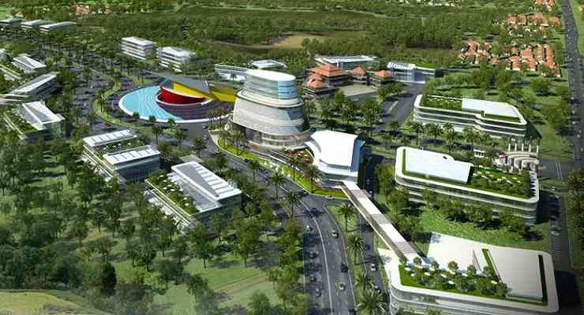

**Figure 1. Kota Baru Parahyangan 3D Planning**

**Source: https://tempatwisatadibandung.info/kota-baru-parahyangan-padalarang-bandung/**

1. Research Method

According to [7], the conceptual approach method proposes seven principles of contemporary architecture. However, Parahyangan Citywalk applies only five principles of the seven principles: dynamic composition, facade transparency, exploration of landscape elements, harmonization of outer and inner spaces, and application of structures. Meanwhile,

stated that a contemporary concept is an architectural style of its time that has the characteristics of a new flow or a combination of several architectural types, freedom of expression, and the desire to display something different[8]. Supported by [9]stated that contemporary architecture could be defined as dynamic architecture created today and will continually change over time. The modern architecture combines various architectural style elements without any stylistic part that stands out. The identity between architecture and local wisdom that comes from the nation's culture in modern times is an important matter to consider in contemporary architecture design. Modern architecture itself has initially been a movement that was a response to technological advances and changing social conditions of society due to the world war. Because research on cultural heritage buildings is still quite extensive and there are not many people who take this theme as the theme of their research[10].

Stated that contemporary architecture could be interpreted as reflecting the architectural flow of the freedom of expression, have a desire to show something different from the others, and a stream of new architecture or can be referred to as a merger of several flow architecture [11], [12]. Furthermore, [2]stated that Contemporary is an everyday thing that exists and is still ongoing today. It can also be anything related to the present.

Stated that the application of the intelligent building concept uses three innovative building principles, namely, performance-based, service-based, and system-based[13]. On this building, only apply two principles, namely, performance-based and service-based.

Based on Kota Baru Parahyangan, the site location is in Kota Baru Parahyangan, Padalarang, Bandung Regency, which is one of urban concepts of a smart city. Kota Baru Parahyangan is located in the Bandung Regency area, where Bandung is the capital city of West Java province in Indonesia. A challenge for the development of this city will also develop several functions that are related to one another, including apartments, educational institutions, office parks, recreational facilities, golf courses, jogging tracks, and art markets. One of the most basic needs in water resource development and management activities is the availability of water. Water is essential for life and is the main factor that is nee[14].

Resorts, housing, and hotels dominate Kota Baru Parahyangan because of the location of Kota Baru Parahyangan, which has potential views. The site location is also surrounded by commercial, educational, and hospital areas.

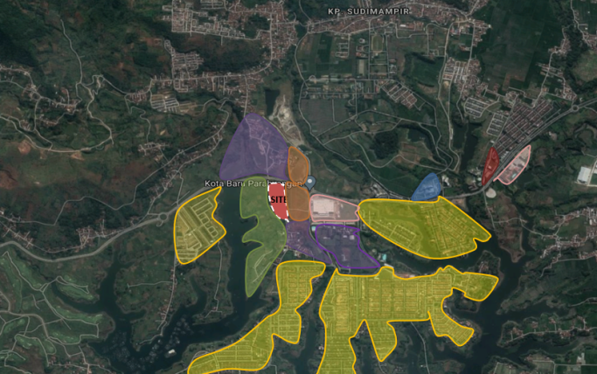

**Figure 2. Zoning Environment at Kota Baru Parahyangan  
Source: https://www.google.com/maps/place/Jl.+Parahyangan+Raya,+Padalarang**

1. Result And Discussion

**Theme Elaboration**

The concept of Parahyangan Citywalk mall uses the concept of contemporary architecture. In its understanding Contemporary Architecture is architecture based on quality, not fixed on specific architectural groupings. This concept combines several styles so that it can respond to various kinds of developments over time. The contemporary architecture is combined in brilliant building facilities where the intelligent building is a theme of this building concept.

An intelligent building can solve building problems technologically and building design intelligence. A building that prioritizes aspects of ease of use and achievement with several infrastructure technologies or problem-solving in any other method. According to [15] stated that intelligent building could be defined as a building technology that consists of the use of sensors, actuators, information and communication technology, intelligence techniques, and technology to control and optimize the use of resources and infrastructure, and offers the best comfort for inhabitants.

Supported by [16], the intelligent building is a continuous integration of advanced information technology. This concept allows the building to be operated remotely throughout the lifecycle comfortably, cost-effectively, and energy-efficient. Meanwhile, ( 2021) [17] stated that a Smart building is defined as a sophisticated building form to be flexible, adaptive, and responsive by utilizing Artificial Intelligence (A.I.) while offering users real-time control. On the other hand, [18] stated that building data systems in intelligent buildings have become increasingly complex and gradually advanced a set of control, control, and management systems which include automatic control systems, intelligent light control systems, multimedia conferencing systems, parking management systems, and others. The innovative city concept running in several cities in Indonesia, especially Bandung City, aims to create a town that functions optimally in managing various city resources effectively and efficiently[19].

In Addition, [20] stated that Smart buildings result from information technology penetration and control technology and the future development direction of the building. This intelligent building system consists of people, a control system, and electronics. Control systems in intelligent buildings establish intellectual connections between people and electronic products for information transmission and mutual feedback. On the one hand, the performance of the control system determines the intelligence building system. On the other hand, people are included in the main service object of the intelligent building system, and the control system's performance also determines the satisfaction level of people in the intelligent building services. Infrastructure development is one of the important and vital aspects to accelerate the national development process, especially in Java, which greatly affects economic and population mobility, especially in 2025 when the population will reach around 151 million people[21].

Meanwhile, [22] stated that the intelligent building concept requires incorporating sensors and big data by leveraging artificial intelligence, which promises a new era of urban energy efficiency. Utilizing artificial intelligence in smart buildings can reduce energy consumption through better control, enhanced upgrades, and automation. Smart building is one of the conceptual representations of modern infrastructure, which includes automated control systems using data to optimize building performance and the level of comfort experienced by the occupants. [23] stated that smart building was defined as providing an efficient environment and optimizing structures, systems, services, and management and the interrelationships between them. Then, the emphasis is on operational efficiency, occupant effectiveness, and information and communication technology. And the third package or operational support buildings reached 75.5038 percent. He is optimistic that the physical construction which is targeted for completion in November-December 2017 will be overtaken[24].

**Site Zoning Concept**

Zoning arrangements on the site are dominated by public areas where this general area is the selling point of the building. The segmentation of the division of this zoning site is placing the public area on the main road area because the general area has no effect on noise and placing the private space in the middle of the shared room and the service as a buffer for the intimate area itself from outside the building. Placement of the service area at the very back to facilitate the circulation of services in and out of the distribution of goods and not interfere with public activities.

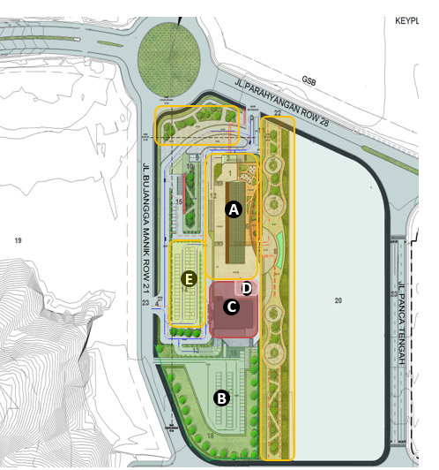

**Figure 3. Zoning Blok Plan**

Parahyangan Citywalk Shopping Center has two entrances: the main entrance facing the Parahyangan Row road and the side entrance facing the green spine. The main hall in the drop-off direction has an increase of 60 cm. This is to avoid the possibility of flooding. While on the side entrance, the green spine is an indentation. At the side entrance to the pool are an LED fountain which is a selling point and a show from the landscape. With this problem, a concept of urban green building emerged. Urban Green Building is a network/system created to reduce/overcome urban areas and climate change problems by involving nature. This research is expected to be a reference for his research and can be developed again to a wider scale. Because research on cultural heritage buildings is still quite extensive and there are not many people who take this theme as the theme of their research[25].

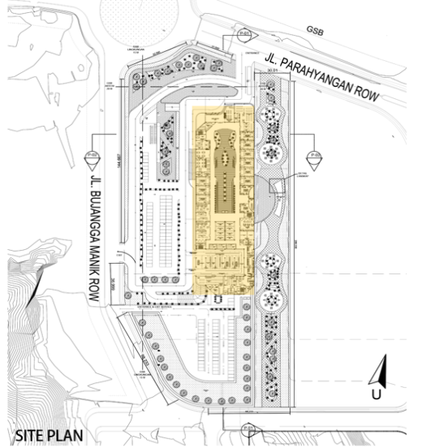

**Figure 4. Hardscape detail**

**Mass Zoning Concept**

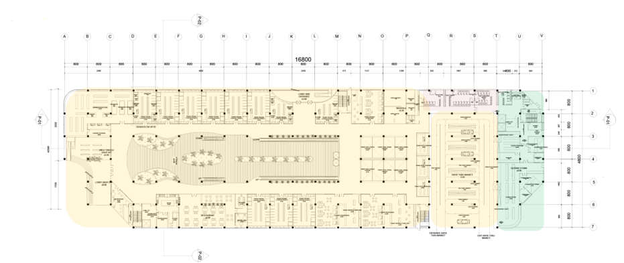Public areas dominate the zoning arrangement on the 1st floor with 85% of the building. This is because the first-floor area is the most potential commercial area. Apart from the price offered for high commercial spaces, the ground floor area can also be an attraction separately for the Parahyangan Citywalk Shopping Center. The use of tenants on the 1st floor is dominated by fashion stores and furniture and anchor tenant areas, including book stores, restaurants, and drive-thru markets.

**Figure 5. First Floor Plan**

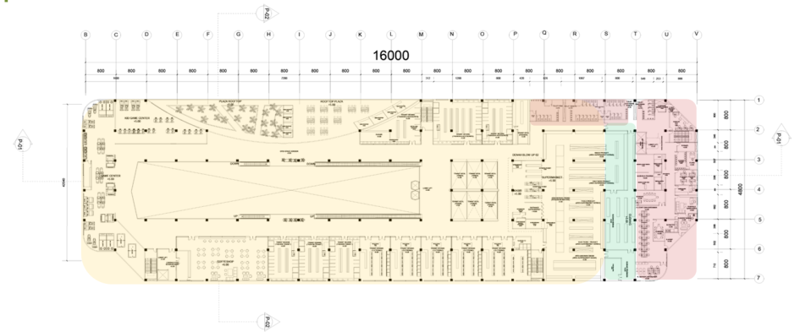Like the zoning arrangement on the 1st floor, the space zoning arrangement on the 2nd floor is also dominated by public areas with 85% of the building. This is because the second-floor site has a potential selling value on the side of the rooftop plaza. Electronic tenants and several fashion tenants dominate the commercial zoning area on the second floor. The second-floor site has three main anchors: a game center, coffee shop, and supermarket. The service area on the second floor is a warehouse for goods focused on supermarkets, while the private area on the second floor is an office area containing staff and managers.

**Figure 6. 2nd Floor Plan**

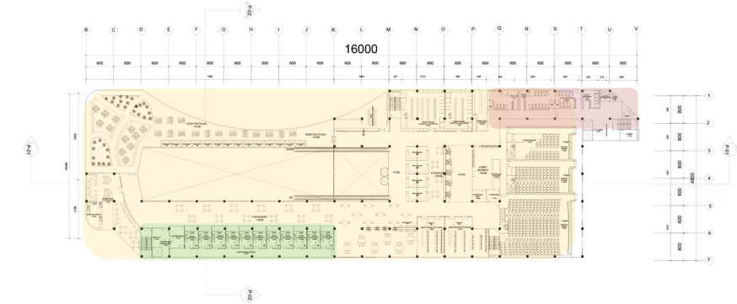The 3rd-floor plan is dominated by food court tenants, where the 3rd-floor area is designated as a dining and drinking area. On the 3rd floor, there are two main anchors, namely a cinema and a coffee shop, while the rest are electronic and fashion tenants. The service area on the third floor is only located in the food court, while the back area only has a private area as a utility room.

**Figure 7. 3rd Floor Plan**

**Building Facade Concept**

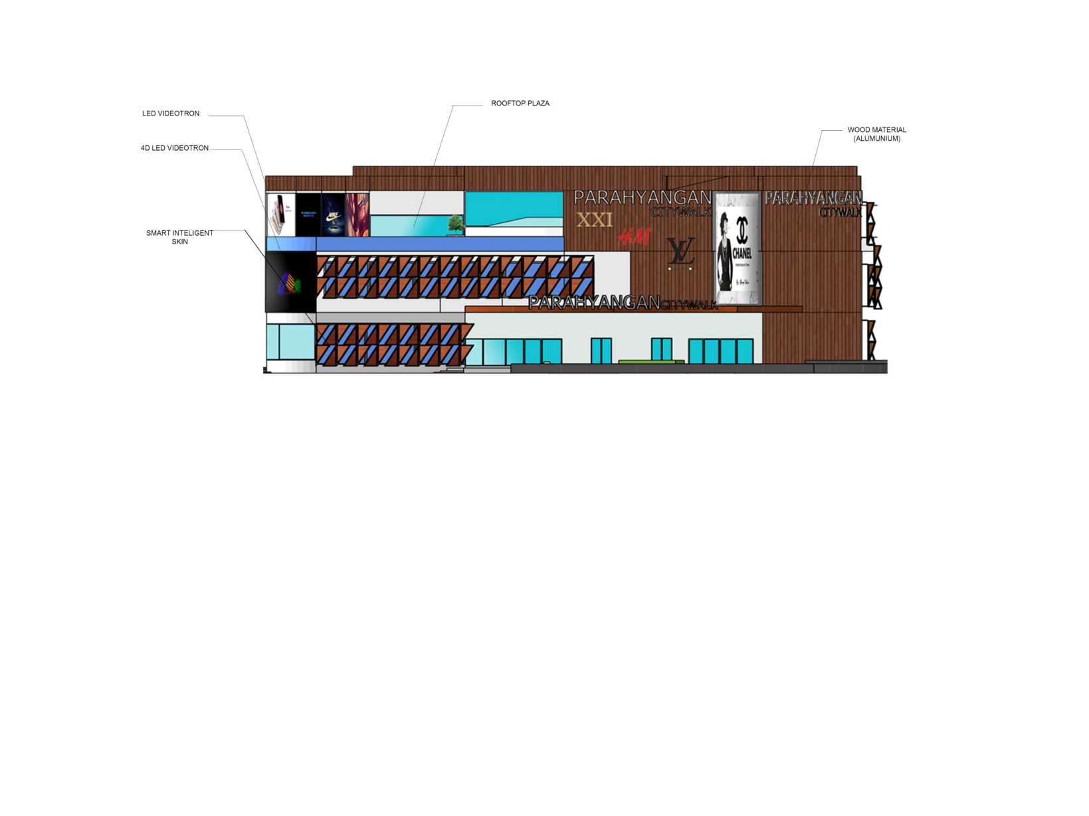The facade of the Parahyangan Citywalk Shopping Center building uses a contemporary architectural concept that adapts the principle of harmonization. The east side of the face of this building provides a rooftop plaza so that visitors from the building mass and the site can be integrated. On a particular side of the facade, this building highlights the theme of an intelligent building, namely the use of 4D LED Videotron as a commercial attraction and the use of automatic windows and intelligence skin as an adaptation of brilliant building performance-based definitions.

**Figure 8. Building Facade**

**Concept of Building Structure**

The building structures at the Parahyangan Citywalk Shopping Center uses composite concrete on their columns and beams. This is because the height of the mall building is not too high and only has three floors. A pile foundation is used in the sub-structure section of the Parahyangan Citywalk Shopping Center building because it is located on slightly contoured soil. Then in the mid structure, the structure uses a composite column measuring 60 cm x 60 cm and a beam of 40 cm x 70 cm., while the use of the design on the roof uses a space frame on the top and concrete on the other roof

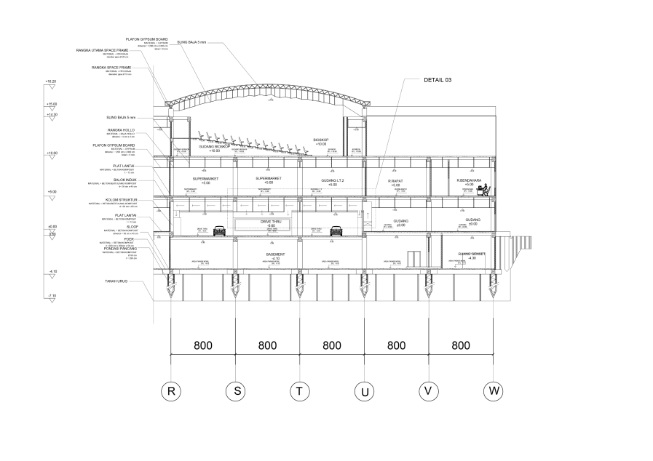

**Figure 9. Building Section**

**Application of Smart Building**

The Intelligence skin facade on the glass tenant glass is controlled automatically with the sensor detector windows located behind the fins of the second skin. Windows sensor detector will respond to commands from the operator with the wireless system and will move the hinge of the secondary skin fin to open and close. The material of the fin itself is made of an aluminum panel with a wood texture so that it can last even when exposed to rain.

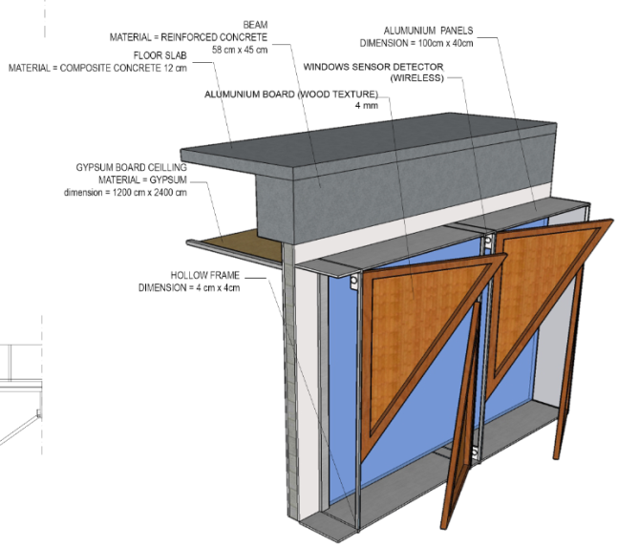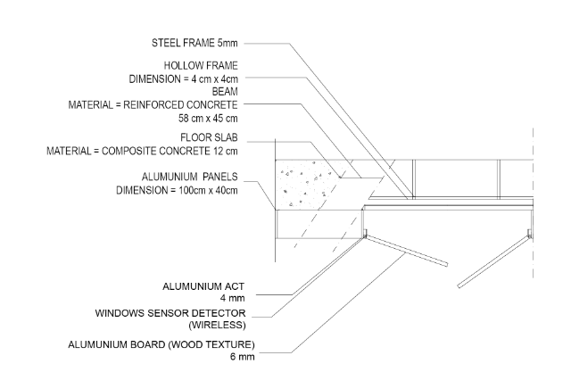

**Figure 10. Intelligence Skin**

The drive-thru market is one solution to technological advances in anticipating a pandemic. The system on the drive-thru allows users to shop without having to come into direct contact with other people in the room. In principle, the distribution of the drive-thru market itself is distributed from the warehouse through a belt conveyor and goes to each rack which the belt conveyor directly distributes. Each item distributed is regulated by the warehouse operator so that there are no errors in the placement of the shelves.

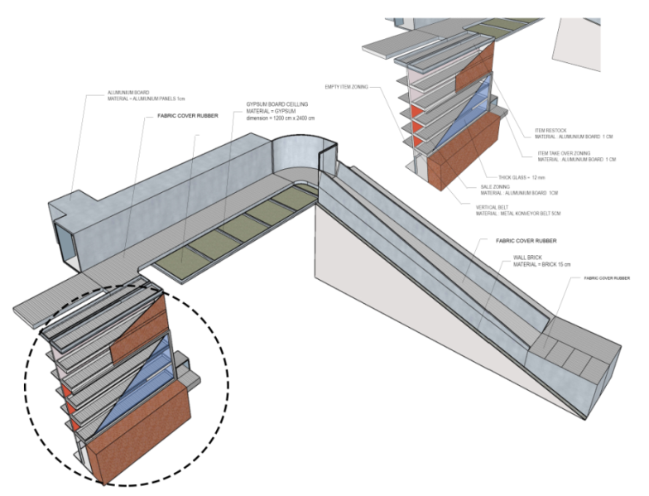

**Figure 11. Drive-Thru Market System**

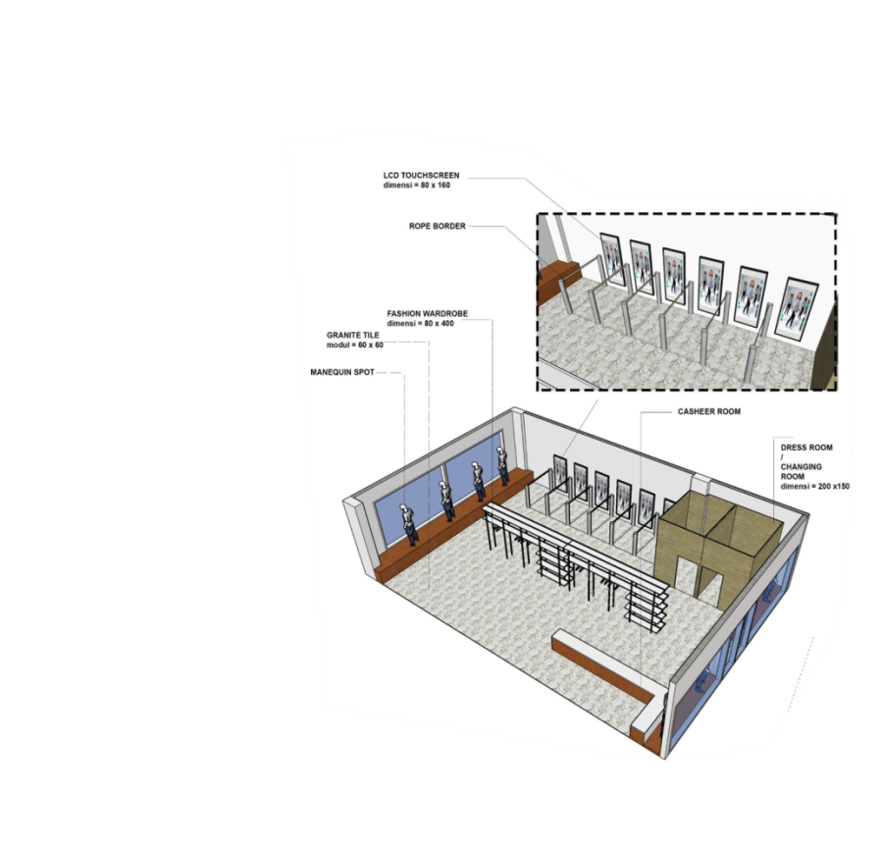Virtual self-checkout is one of the technologies applied to fashion stores where. This virtual self-checkout allows buyers to measure the clothes of their own choice without going to the locker room. The use of virtual self-checkout is like a mirror that can show the whole body with various available settings. This facility will minimize queues from product buyers.

**Figure 12. Interior of Virtual Self Checkout**

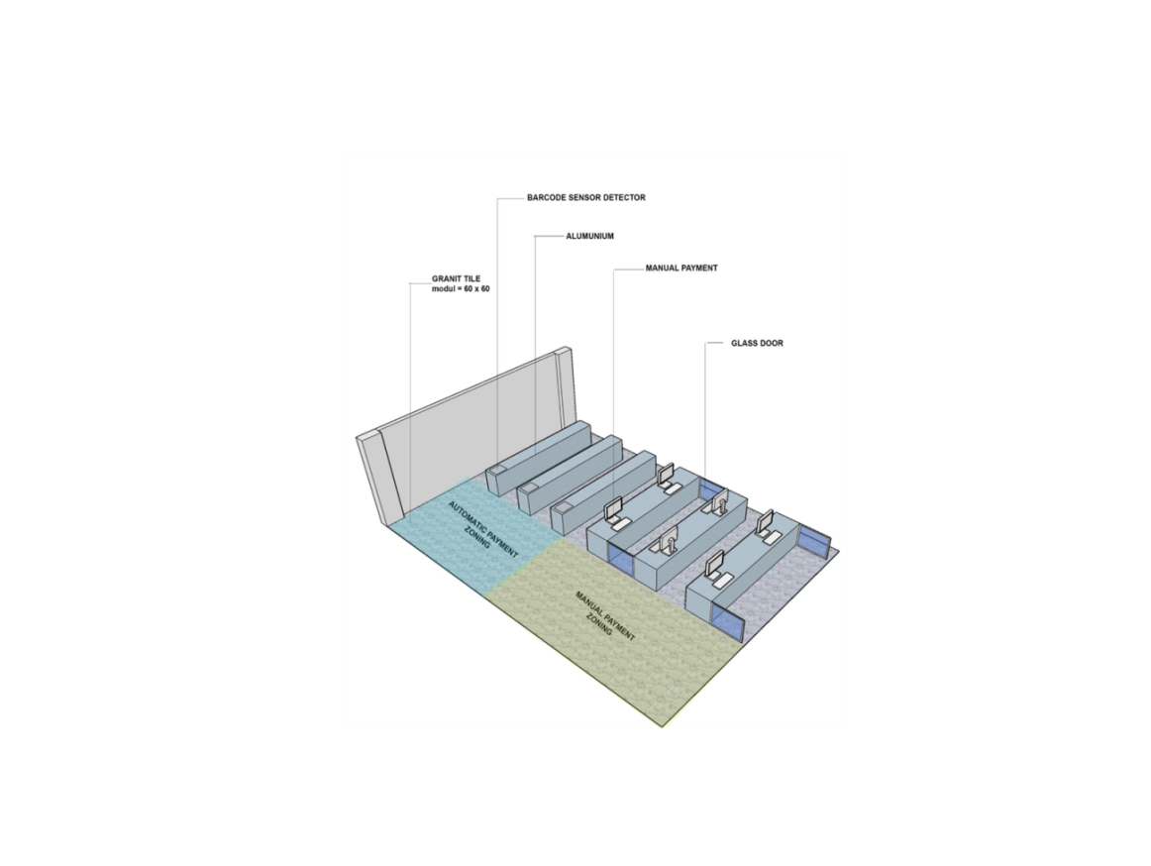While virtual payment is a facility where buyers only show the barcode on the sensor at the cashier. So there is no need to queue. The barcode will later be integrated with each user's ATM.

**Figure 13. Virtual Payment**

**Exterior and Interior**

The exterior of the Parahyangan Citywalk Shopping Center building is integrated with the rooftop plaza area on the east side of the building. This is so that the green spine area comes alive with the rooftop plaza. The West and East facades have different treatments, where the East facade exposes large openings due to the attractiveness of the green spine and integration. In contrast, the East facade is closed using intelligent skin to minimize sunlight.

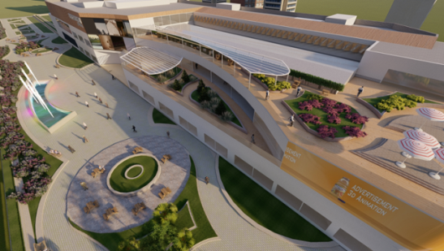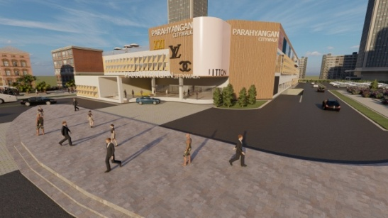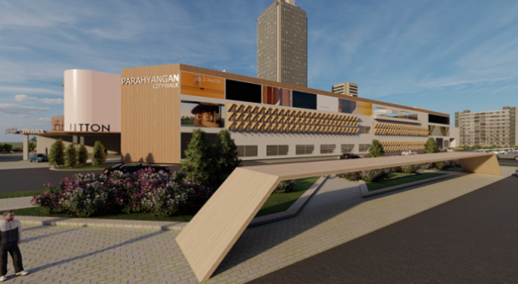

**Figure 14. Exterior Perspective**

The interior of the Parahyangan Citywalk Shopping Center building is dominated by white to show an elegant impression and increase each operating tenant's selling value. The atrium's interior is deliberately expanded so that natural lighting from the skylight can directly lead to the building. The interior concept applies one of the seven principles of contemporary architecture by [26], which harmonizes outer and inner space.

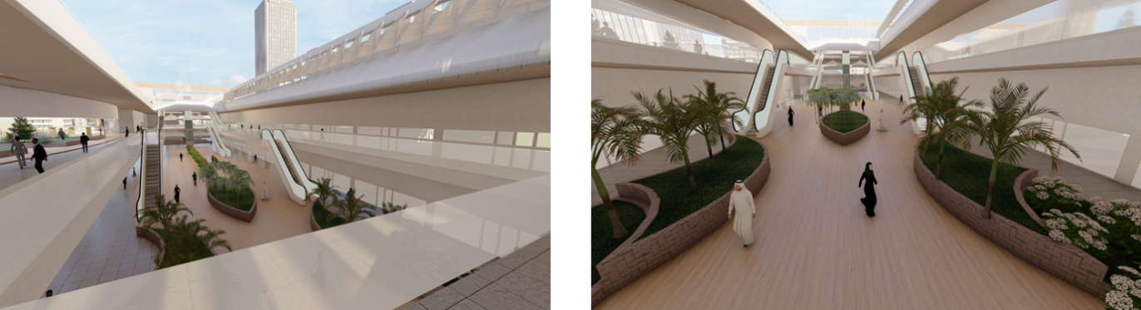

**Figure 15. Interior Perspective**

1. Conclusion

Parahyangan CitywalkShopping Center is a shopping center building concept that applies a contemporary design style with a semi-indoor approach. This concept maximizes the potential that exists around the building. Intelligent buildings are used to create an innovative shopping center to become a reference in intelligent building technology. This concept was created because shopping centers face pretty heavy competition in the era of industrial revolution 4.0, where the influence of digital media is getting more intense, so people will think twice about going to shopping centers. Therefore, a shopping center design has been created that dwells on shopping center facilities and accommodates other life activities so that the shopping center can attract visitors. Two implementations of the concept in this shopping center are combining a shopping building with the application of Contemporary Architecture, which is expected to be an attraction for the Parahyangan Citywalk Shopping Center building for the next few years and by applying innovative smart building technology that application performance and service so that it can compete with others in the development of the digital era.

Acknowledgements

I would like to thank the developer of Kota Baru Parahyangan Lyman Group, originally named Satya Djaya Raya (SDR) Group. Who has provided primary and secondary data for the Kota Baru Parahyangan.

References

[1] Y. Sumalyo, *Arsitektur Modern: Akhir Abad XIX dan Abad XX. Edisi ke 2*. Gadjah Mada University Press, 2005.

[2] R. W. Pratama and E. Marlinna, “Penerapan Karakteristik Arsitektur Kontemporer Pada Perancangan Pusat Pelatihan Sepak Bola Pss Sleman,” *PURWARUPA J. Arsit.*, vol. 4, no. 1, pp. 81–86, 2020.

[3] H. Ohta *et al.*, “Cross talk between hedgehog and epithelial–mesenchymal transition pathways in gastric pit cells and in diffuse-type gastric cancers,” *Br. J. Cancer*, vol. 100, no. 2, pp. 389–398, 2009.

[4] S. Novopysmennyi *et al.*, “Implementation of electronic health control technologies in higher education institutions,” *J. Phys. Educ. Sport*, no. 20 (2), pp. 921–928, 2020.

[5] B. Prasetyo and U. Trisyanti, “Revolusi industri 4.0 dan tantangan perubahan sosial,” *IPTEK J. Proc. Ser.*, no. 5, pp. 22–27, 2018.

[6] R. C. Dorf, *The technology management handbook*. CRC Press, 1998.

[7] E. Schirmbeck, *Idea, Form, and Architecture: Design Principles in Contemporary Architecture*. Van Nostrand Reinhold Company, 1987.

[8] A. A. Al Rafid and H. Iskandaria, “Perancangan Pondok Pesantren Modern Dengan Pendekatan Arsitektur Kontemporer Di Kelurahan Limbangan Wetan, Kecamatan Brebes, Kabupaten Brebes, Jawa Tengah,” *MAESTRO*, vol. 2, no. 2, pp. 262–268, 2019.

[9] F. Aini and M. Safeyah, “Kajian Konsep Arsitektur Kontemporer Pada Interior Jakarta Creative Hub,” *WIDYASTANA J. Mhs. Arsit.*, vol. 1, no. 02, pp. 127–134, 2020.

[10] A. Andiyan and O. Nurrisman, “Implementation of the New Function of the Sarinah Braga Building (Hotel De Braga By Artotel),” *Solid State Technol.*, vol. 64, no. 2, pp. 5689–5695, Feb. 2021, Accessed: May 21, 2021. [Online]. Available: http://solidstatetechnology.us/index.php/JSST/article/view/10569.

[11] L. Hilberseimer, *Contemporary Architecture the Roots and Trends*. Chicago: Chicago, Il: PAul Theobald and Company, 1964.

[12] A. M. Augita, M. A. Nirawati, and Y. Winarto, “Penerapan Prinsip Arsitektur Kontemporer Dalam Perancangan Ruang Kreatif Di Surakarta,” *Senthong*, vol. 2, no. 1, 2019.

[13] S. Wang, *Intelligent buildings and building automation*. Routledge, 2009.

[14] E. B. Andiyan Andiyan, “Penerapan Konsep Arsitektur Kontemporer pada Penataan Cagar Budaya Situ Tasikardi,” *Syntax Lit. J. Ilm. Indones.*, vol. 6, no. 6, pp. 2624–2636, 2021, [Online]. Available: http://jurnal.syntaxliterate.co.id/index.php/syntax-literate/article/view/3163/2157.

[15] C. Benavente-Peces, “On the energy efficiency in the next generation of smart buildings—Supporting technologies and techniques,” *Energies*, vol. 12, no. 22, p. 4399, 2019.

[16] A. Yang, M. Han, Q. Zeng, and Y. Sun, “Adopting Building Information Modeling (BIM) for the Development of Smart Buildings: A Review of Enabling Applications and Challenges,” *Adv. Civ. Eng.*, vol. 2021, 2021.

[17] J. M. Jacob, R. Ravindran, M. Narayanan, S. M. Samuel, A. Pugazhendhi, and G. Kumar, “Microalgae: A prospective low cost green alternative for nanoparticle synthesis,” *Curr. Opin. Environ. Sci. Heal.*, vol. 20, p. 100163, 2021.

[18] M. Zhang, H. Lv, H. Chen, and Q. Hu, “Analysis of constraints on data management of intelligent platform for smart building in the era of big data,” in *IOP Conference Series: Earth and Environmental Science*, 2021, vol. 768, no. 1, p. 12109.

[19] M. A. Kurniawan and A. Andiyan, “Disrupsi Teknologi Pada Konsep Smart City: Analisa Smart Society Dengan Konstruksi Konsep Society 5.0,” *J. Arsit. Arch.*, vol. 4, no. 2, pp. 103–110, 2021.

[20] M. Li, “A calculation method for assessing the social benefits of a sponge city: a case study for the Peiyang Park Campus, Tianjin University,” *Earth Sci. Front.*, vol. 27, no. 3, pp. 281–289, 2020, doi: 10.13745/j.esf.sf.2020.4.40.

[21] A. Andiyan, Rachmat, “Analisis Manfaat Pembangunan Infrastruktur Kereta Api Di Pulau Jawa,” *J. Pendidik. dan Teknol. Indones.*, vol. 1, no. 3, pp. 121–129, 2021.

[22] H. Farzaneh, L. Malehmirchegini, A. Bejan, T. Afolabi, A. Mulumba, and P. P. Daka, “Artificial Intelligence Evolution in Smart Buildings for Energy Efficiency,” *Appl. Sci.*, vol. 11, no. 2, p. 763, 2021.

[23] P. A. Fokaides *et al.*, “Research challenges and advancements in the field of sustainable energy technologies in the built environment,” *Sustainability*, vol. 12, no. 20, p. 8417, 2020.

[24] A. Andiyan and A. Rachmat, “Telaahan Kerjasama Pemerintah Swasta Dalam Pembangunan Bandara Kertajati Di Jawa Barat,” *Aksara J. Ilmu Pendidik. Nonform.*, vol. 7, no. 2, pp. 413–424, May 2021, doi: 10.37905/AKSARA.7.2.413-424.2021.

[25] A. Andiyan and A. Nurjaman, “Pendekatan Urban Green Building Pada Bangunan Apartemen,” *RADIAL J. Perad. Sains, Rekayasa dan Teknol.*, vol. 9, no. 1, pp. 39–52, 2021.

[26] E. Schimbeck, *Gagasan, bentuk, dan arsitektur. Prinsip-prinsip perancangan dalam arsitektur kontemporer.* Bandung: Intermatra, 1988.