
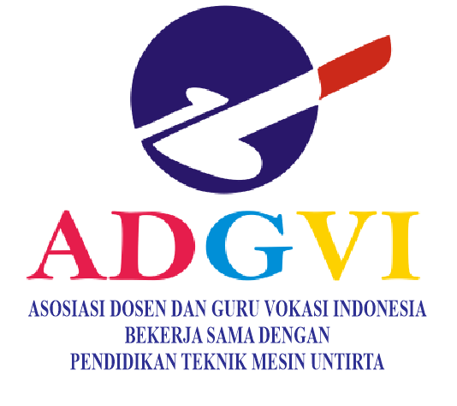
j
VANOS
JOURNAL OF MECHANICAL ENGINEERING EDUCATION
http://jurnal.untirta.ac.id/index.php/vanos
ISSN 2528-2611, e-ISSN 2528-2700
Vol.2, No.2, Desember 2017, Hlm.x-x.

FAILURE OF 150 KV POWER TRANSFORMER IN INDICATION OF DISSOLVED GAS ANALYSIS TEST IN TOTAL DISSOLVED COMBUSTILE GAS (TDCG) METHOD

Irwanto

Electric Engineering Vocational Education, Faculty of Teacher Training and Education
University of Sultan Ageng Tirtayasa
Jl. Ciwaru Raya, No. 25, Serang, Banten, 42117
Corresponding author: irwanto.ir@untirta.ac.id

Accepted: 13 March 2016. Approved: 23 March 2016. Published: 23 April 2016 (Cambria 10, Centered)

ABSTRACT

A transformer is an electrical device to change the voltage from one level to a certain level with the same frequency that is generated from the generator. This transformer is used in a power plant to increase the voltage from the generator to be supplied to extra high voltage substations. By knowing the type and amount of gas in the transformer oil, it can be seen that the failure occurred. Preventive steps can be taken before the transformer is more severely damaged or a breakdown which will result in disrupted and detrimental electrical energy supply. The method used in this research is data collection methods used are observation, interviews and participation conducted at PT. Krakatau, Serang Banten. The method used to determine the failure of the transformer is the Dissolved Gas Analysis (DGA) method. The DGA test uses several methods to interpret the data, these methods are Total Dissolved Combustile Gas (TDCG), Key Gasses, Doernenburg Ratio, Roger's Ratio, IEC Ratio and Duval's Triangel. The method used in this research is direct observation of the process of taking transformer oil samples and testing transformer oil samples with the Transport-X tool. The result of this research is that the transformer condition is still in normal condition, because the appearance of CO2 gas has almost crossed the condition limit, so other supporting methods are needed to find the cause of the gas. Key gasses indicate the presence of overheating of paper insulation, IEC Ratio diagnoses transformer failure caused by heat failure at temperatures of 300o-700o C, Duval's Triangel diagnoses transformer failure caused by temperatures over 700o and this method supports the previous analysis. With this method, overheating occurs at certain points (hotspots) in the internal transformer. Preventive maintenance is needed to conform to the standard of the transformer.

Keywords: transformer, DGA test, TDCG method, power, indication

PRELIMINARY
Considering the very important role of the transformer, the failure of transformer operation is highly undesirable because it will have an adverse impact on production at PT. Krakatau Daya Listrik and other industries that supply the electrical energy needs of PT. Krakatau Daya Electric. Therefore, the transformer must always be maintained in an optimal condition to prevent damage or breakdown of the transformer isolation so that it can cause the transformer to suddenly stop operating.
If there is interference with the transformer due to thermal or electrical disturbances, gases will appear in the transformer oil. By knowing the type and amount of gas in the transformer oil, it can be seen the disturbance that occurs. So that preventive steps can be taken before the transformer is more seriously damaged. This method is known as DGA (Dissolved Gas Analysis). [1] said that a transformer is an electrical device that can transfer and convert electrical energy from one or more electrical circuits to another, through a magnetic coupling and based on the principle of electromagnetic induction. A transformer is a static electromagnetic electric device that functions to move and convert electrical power from one electrical circuit to another, with the same frequency and a certain transformation ratio through a magnetic coupling and works based on the principle of electromagnetic induction, where the ratio of the voltage between the primary side and the secondary side is directly proportional to the number of turns and inversely proportional to the current [2].
So, a transformer is an electrical device that functions to transfer and convert electrical energy from one circuit to another using the principle of electromagnetic induction. Transformers are widely used, both in the field of electric power and electronics. The use of a transformer in the power system allows selecting the appropriate and economical voltage for each need, for example the need for high voltage in long-distance electrical power delivery [1].
Below is the basic construction of a transformer obtained from the Transformer Theory book written by [3], as in Picture 1 below.

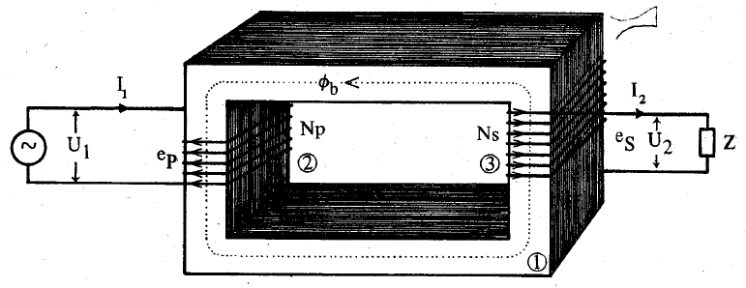
Picture 1. The basic construction of the transformer

Information:
- The core / terrace / kren.
- Primary winding connected to a power source.
- The secondary winding is connected to the load.
If the primary coil is connected to the voltage (source), it will flow an alternating current of I1 on the coil. Because the coil has a current core, I1 causes a magnetic flux that also changes in essence. As a result of changing magnetic flux, the primary coil arises ep-induced emf [3]. The amount of induced emf in the primary coil is:

e_{p}=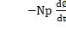
Where:
e_{p} : GGL induction on the primary coil
N_{p} : Number of turns of the primary coil
dФ : Changes in the lines of magnetic force in weber units ( 1 weber = 10⁸ Maxwell)
dt : Time changes in seconds.

The magnetic flux that induces ep-induced EMF is also experienced by the secondary coil because it is a mutual flux. Thus the flux induces ice-induced EMF on the secondary coil. In the book The Electrical Engineering Handbook (2000), transformers are classified into two main categories, namely dry type transformers and liquid-filled transformers.
First, Dry Transformer is cooled by natural air circulation or forced circulation or natural inert gas through or around the transformer enclosure. Dry Transformers are further divided into vented, sealed, or encapsulated types depending on the transformer construction. Dry Transformers are widely used in industrial power distribution for voltages up to 5000 kVA and 34.5 kV.
Second, the Liquid-filled Transformer is cooled by natural or forced circulation of coolant through the transformer windings. This fluid serves as a dielectric to provide superior stress resistance characteristics. The most common liquid used in transformers is mineral oil or what is known as Transformer Oil which has a continuous operating temperature of 105oC, a flash point of 150oC, and a fire point of 180o C [4]. A good transformer oil has a breakdown voltage strength of 86.6kV/cm (220kV/in) which is much higher than the penetration power of 9.84 kV/cm (25kV/in) at atmospheric pressure. Silicone liquid is used as an alternative to Mineral Oil. The breakdown strength of silicon fluid exceeds 118 kV/Cm (300kV/in) and has a flash point of 300ºC and a fire point of 360ºC [5]. The liquid-filled silicon transformer is non-flammable, the high dielectric strength and the superior thermal conductivity of the coolant make it ideal for high-voltage power transformers used in modern power generation and distribution generators [6].
Transformer oil is a liquid insulating material, this oil is widely used as a dielectric in transformers [7]. The main function of transformer oil is as an insulating medium between parts that contain a potential difference so that there is no electric jump (flash-over) or spark (spark-over), and other functions as a cooling medium on transformers, power cables, or as a medium. arc extinguisher on the circuit breaker [8].
Mineral insulating oil is formed from several hydrocarbon molecules containing chemical groups CH, CH2, and CH linked by carbon molecular bonds. The breaking of some CH and CC bonds can occur as a result of electrical and thermal disturbances, with the form of small, unstable fractions, in the form of radicals or ions such as H*, CH3*, CH2*, CH*, or C* (among other, more advanced forms. complex) which recombine rapidly through complex reactions to form gas molecules such as hydrogen HH methane CH, 3-H ethane CH3-CH3 ethylene CH2 = CH2 or acetylene CH = CH, these gases are known as fault gases. These gases accumulate as free gas if they form in large quantities and in a fast time [9].
When the oil decomposes due to heat, cellulose insulation produces CO and CO2 and some H2 and CH4 in the oil. The degree to which the compound is formed depends on the temperature and volume of the material at that temperature, with two processes, namely [10]: (1) The over heating process, when cellulose/paper is heated by over heating (at least 140º C) in a closed system according to conditions transformer, then the decomposition of cellulose into carbon monoxide (CO) and carbon dioxide (CO2) gas, and (2) the pyrolysis process, when cellulose is heated to decompose by pyrolysis and temperatures above 250º C in a closed system, more carbon will be formed. monoxide (CO) rather than carbon dioxide (CO2) with an amount roughly four times greater than CO2.
Transformer oil is a complex mixture of hydrocarbon molecules, in linear or cyclic form, which contains bonded groups of CH3, CH2 and CH molecules. The breaking of several bonds between the elements CH and CC as a result of thermal or electrical failure will produce ion fragments such as H, CH3, CH2, CH or C, which will later recombine and produce gas molecules such as hydrogen (HH), methane ( CH3-H), ethane (CH3-CH3), ethylene (CH2 = CH2) or acetylene (CH=CH). These gases are known as fault gases, as in Picture 2 below.

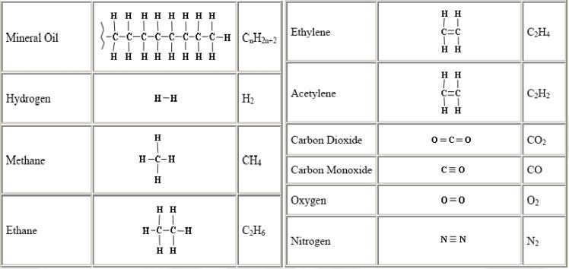
Picture 2. Chemical structure and dissolved gas in transformer oil [11]

In addition, transformer oil must have the property of dissolving gases, especially flammable gases. This is intended to prevent flammable gases, especially gases. With the dissolved gas in oil in the transformer, it can be used to detect and estimate the condition of the transformer that is currently operating [12].

Gas Cromatograph
The technique of separating certain substances from a compound compound based on their level of evaporation (volatility). The way it works is based on the absorption properties of the cromatographic gas column system to the sample. The injected sample will be streamed by the carrier gas. The gases which have different absorption properties will be separated. The separation of these gases will be detected by the detector which is converted into the recording system. The type and amount of gas can be determined by comparing it with the amount of standard gas whose composition is previously known as in Picture 3 below.
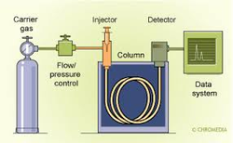
Picture 3. Gas cromatograph

Photoacoustic Spectroscopy basically has a unique and distinctive electromagnetic radiation absorption capability. This ability is usually applied to the infrared spectroscopic method to produce photo acoustic effects. The absorption of electromagnetic radiation by gases will increase the gas, as in Picture 4 below [13].
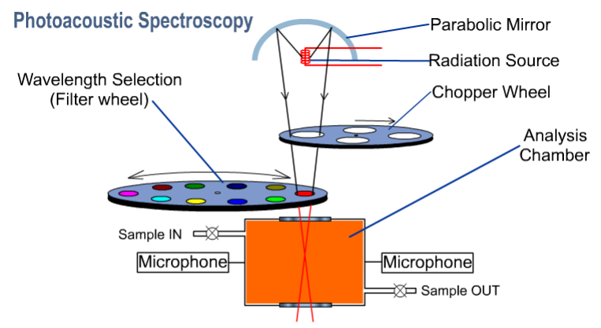
Picture 4. Photoacoustic spectroscopy [14]

DGA can literally be interpreted as an analysis of the condition of the transformer which is carried out based on the amount of dissolved gas in the transformer oil. The DGA test is carried out on an oil sample taken from the transformer unit then the dissolved gases are extracted. The gas that has been extracted is then separated, its individual components are identified, and the quantity is calculated (in ppm units) [15].
The main advantage of the DGA test is early detection of failure phenomena that exist in the transformer under test. But the main drawback is that it requires a high level of purity of the oil samples tested. On average, the DGA test equipment has a high sensitivity, so that the impurity of the sample will reduce the accuracy of the DGA test results. PT. Krakatau Daya Listrik. Using a tool in the form of TRANSPORT X made by KELMAN which uses the Photoacoustic Spectroscopy method. The ability of gases to absorb electromagnetic radiation, such as infrared light, causes photoacoustics [16].

Absorbed electromagnetic radiation causes the temperature of the gas to increase so that it also increases the gas pressure in the test tube. By adjusting the light source, the gas pressure also fluctuates which will cause the amplitude of the pressure to be detected using sensitive microphones, as in Picture 5 below.

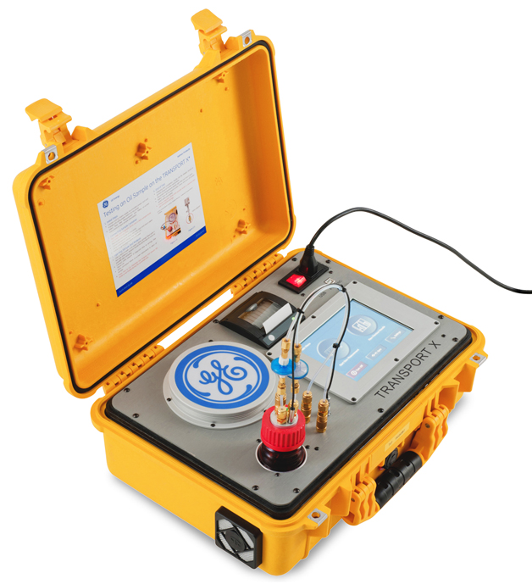
Picture 5. DGA test equipment

The DGA test was conducted using four different methods, namely TDCG, Key Gases, Doernenburg Ratio, Roger's Ratio, and Duval's Triangle [17].

RESEARCH METHODS
The type of research used is qualitative with a descriptive approach. The data collection methods used are: (1) direct observation, where the method used is direct observation and direct recording of the voltage, current, and temperature indicators as well as the results of measurements on the preventive maintenance carried out on the distribution transformer.
(2) interviews, this method is used to collect data by conducting interviews and question and answer as well as discussions with sources or employees of the company. (3) participatory method, this method is used to collect data by being directly involved in in-line and off-line preventive maintenance activities of the TRF-2011 A distribution transformer by inspecting the station and measuring insulation resistance, winding resistance, breakdown voltage insulating oil and cleaning [18].
Direct observation of the transforamtor oil testing process A method that is carried out by directly observing the transofrmator oil testing process with a tool called TRANSPORT X. This test is carried out in a Quality Control Maintenance room. System planning and data retrieval, system planning is the stage of developing an existing system or determining a series or framework under study. Once found, the authors retrieve the data in accordance with the system planning that has been made.

RESULTS AND DISCUSSION
Mineral insulating oil is formed from several hydrocarbon molecules containing CH₁, CH₂, and CH chemical groups connected by carbon molecular bonds. The breaking of some CH and CC bonds can occur as a result of electrical and thermal disturbances, in the form of small, unstable fractions, in the form of radicals or ions such as H *, CH₃ *, CH₂ *, CH *, or C * (among other, more complex) which recombine rapidly through complex reactions to form gas molecules such as hydrogen HH methane CH₃-H ethane CH₃-CH₃ ethylene CH₂ = CH₂ or acetylene CH = CH, these gases are known as fault gases.
This analysis method is based on the amount of flammable gases detected in the transformer oil, namely CH₄, C₂H₂, C₂H₄, C₂H₆, H₂ and C_{O}. After knowing the types and amounts of gases contained in the insulating oil, the data obtained were compared with the amount of gas limits allowed under the IEEE C57.104.2008 standard. Condition 1, the transformer is operating normally. However, it is still necessary to monitor the condition of these gases. Condition 2, TDCG in this condition indicates the gas composition has exceeded the normal limit. There may be symptoms of failure that must be watched out for. More routine and frequent oil sampling is required. Condition 3, TDCG at this level indicates the decomposition of the insulation paper and / or transformer oil. One or more failures may have occurred. In this condition the transformer must be watched out for and need further maintenance. Condition 4, TDCG at this level indicates decomposition/damage to the paper insulator and/or transformer oil has been widespread. Continuing transformer operation can lead to transformer failure [19].
The Doernenburg Ratio Method uses four different gas ratios to indicate the type of failure that may occur. These disturbances are in the form of Partial Discharge, Arching and Thermal faults as in Table 1 below.
Table 1. Types of Faults based on the Doernenburg Ratio

Rasio Doernenburg |  | AT04 | Keterangan
RATIO 1 | CH4/H2 | 1.66 | Tidak dapat digunakan
RATIO 2 | C2H2/C2H4 | 0 | Tidak dapat digunakan
RATIO 3 | C2H2/CH4 | 0 | Tidak dapat digunakan
RATIO 4 | C2H6/C2H2 | 0 | Tidak dapat digunakan

Roger's Ratio Method uses four gas ratios namely R1 (CH₄ / H₂), R₃ (C₂H₆ / CH₄), R5 (C₂H₄ / C₂H₆) and R2 (C₂H₂ / C₂H₄) for diagnosis (table. 2). This method is based on the principle of thermal degradation and is included in the IEEE Standard C57.104-2008 [20].
Roger's Ratio method uses two tables, one defines the ratio code, and the second determines the rules of diagnosis. The following is a table of Code Definition and Diagnosis Rules as in Table 2 below.
Table 2. Code definition of the Roger ratio
Rasio Gas | Range | Kode
R1 | <0.1 | 5
R1 | >0.1 dan <1.0 | 0
R1 | >1.0 dan < 3.0 | 1
R1 | >3.0 | 2
R3 | <1.0 | 0
R3 | >1.0 | 1
R5 | <1.0 | 0
R5 | >1.0 dan < 3.0 | 1
R5 | < 3.0 | 2
R2 | <0.5 | 0
R2 | >0.5 dan < 3.0 | 1
R2 | >3.0 | 2

Table 3. Type of Failure based on Code Definition
R1 | R3 | R5 | R2 | Diagnosis Kegagalan
0 | 0 | 0 | 0 | Normal Deterioration
5 | 0 | 0 | 0 | Partial Discharger
½ | 0 | 0 | 0 | Thermal Fault < 150ᵒC
½ | 1 | 0 | 0 | Thermal Fault < 150-200ᵒC
0 | 1 | 0 | 0 | Thermal Fault < 150-300ᵒC
0 | 0 | 1 | 0 | Overheating in the Cables
1 | 0 | 1 | 0 | Circulating current in the Windings
1 | 0 | 2 | 0 | Circulating current in the tank and core, overheating in the conexions
0 | 0 | 0 | 1 | Conexions Discharger
0 | 0 | ½ | ½ | Arching (high energy)
0 | 0 | 2 | 2 | Low intensity continuous discharger
5 | 0 | 0 | ½ | Partial Discharger involving solid instulation

The IEC Ratio Method comes from Roger's Ratio Method, however Ratio 3 (C₂H₄/CH₄) is not used because R3 only indicates a limited range of decomposition temperatures.
Similar to Roger's Ratio Method, the IEC Ratio Method also uses 2 types of tables, namely the Code Definition table and the Failure Clarification Table as in Table 4 below.

Table 4. IEC Ratio Method Definition Code
Range of Gas Ratio | Codes of Different gas Ratio
Range of Gas Ratio | R2  (C₂H₂/C₂H₄) | R1  (CH₄/H₂) | R5  (C₂H₄/C₂H₆)
<0.1 | 0 | 1 | 0
0.1-1 | 1 | 0 | 0
1-3 | 1 | 2 | 1
>3 | 2 | 2 | 2

This method uses a ratio that utilizes hydrocarbon gas. However, in this method only three compounds were compared. Methane (CH₄), ethylene (C₂H₄), and acetylene (C₂H₂) gases were compared to the accumulated amount of the three gases, as in Picture 6 below.

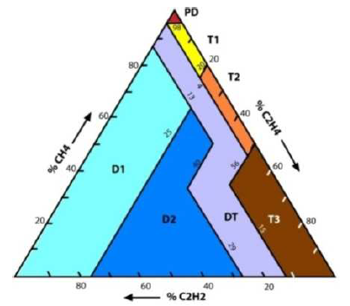
Picture 6. Duval's Triangel

There are seven disturbances that become the interpretation of the composition of the three gases, namely:
PD = Partial Discharge
T1 = Thermal Fault Less than 300 °C
T2 = Thermal Fault Between 300 °C and 700 °C
T3 = Thermal Fault Greater than 700 °C
D1 = Low Energy Discharge (Sparking)
D2 = High Energy Discharge (Arcing)
DT = Mix of Thermal and Electrical Faults
- Total Dissolved Combustile Gas (TDCG)
To analyze the internal conditions of the 150kV AT04 KDL Power Transformer, it is necessary to interpret the results of the Transformer Oil DGA test. The following is the data from the DGA test results on the 150 kV AT04 PT.KDL Power Transformer Oil sample taken on October 31, 2018, when Predictive Maintenance (Annualy) was carried out.

Table 5. DGA Test Results
GC DATA OF GASES ARE EXPRESSED IN PPM (PART PER MILLION)
H2 | CO2 | CO | C2H4 | C2H6 | CH4 | C2H2 | TDGC
100 | 2500 | 350 | 50 | 65 | 120 | 25 | 720
3 | 2437 | 53 | 5 | 3 | 5 | 0 | 69

From Table 5 above it can be explained that the AT04 Power Transformer condition is in Condition 1 because the TDCG concentration value is within normal limits (TDCG <720). Condition 1 indicates that the transformer is operating normally, but it is still necessary to monitor the condition of the gases.
- Analisa Key Gas Method
Table 6. Key Gasses Concentration
Nama Gas | Konsentrasi | Persentase (%)
CO | 53 | 76.81
H2 | 3 | 4.34
CH4 | 5 | 7.24
C2H6 | 3 | 4.34
C2H4 | 5 | 7.24
C2H2 | 0 | 0
TDCG | 69 | 100

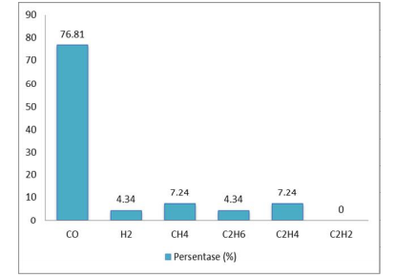
Picture 6. Key Gasses Percentage Graph
Carbon monoxide (CO) gas is the Key Gases to indicate excessive heat in paper insulation (Overheated Celullose).
- Analisis Doernenburg Ratio Method
The requirements needed to use the Doernenburg ratio analysis are:
- At least one gas concentration (H₂, CH₄, C₂H₂, C₂H₄, C₂H₆) exceeds twice the limit of Condition 1 in (table 7)
- One of the other two gases (C₂H₆ and C_{O}) exceeds the limit of Condition 1 (table 7) below.

Table 7. Doernenburg Ratio DGA Test
Rasio Doernenburg |  | AT04 | Keterangan
RATIO 1 | CH4/H2 | 1.66 | Tidak dapat digunakan
RATIO 2 | C2H2/C2H4 | 0 | Tidak dapat digunakan
RATIO 3 | C2H2/CH4 | 0 | Tidak dapat digunakan
RATIO 4 | C2H6/C2H2 | 0 | Tidak dapat digunakan

DGA sample data that has been made into the table above shows that the conditions above are not met. So that Doernenburg's analysis cannot be applied and analyzed further.
- Analisis Roger’s Ratio Method
Table 8. Code Definition of DGA Test Results
Rasio Gas | Hasil | Range | Kode Definisi
R1 | 1.66 | >1.0 dan <3.0 | 1
R3 | 0.6 | <1.0 | 0
R5 | 1.6 | >1.0 dan <3.0 | 1
R2 | 0 | <0.5 | 0

Based on the Code Definition that has been found, there is a match with the Type of Failure in Table 6.
Type of Failure is based on Roger's Ratio analysis, namely Circulating Current in the Winding.
- Analisis IEC Ratio Method
Table 9. Comparison Results of the IEC Ratio Method

IEC Ratio |  | Hasil | Case
Rasio 1 | CH4/H2 | 1.02 | Thermal Fault of Medium Themperature 300ᵒ-700ᵒC
Rasio 2 | C2H2/C2H4 | 0 | Thermal Fault of Medium Themperature 300ᵒ-700ᵒC
Rasio 5 | C2H4/C2H6 | 1.6 | Thermal Fault of Medium Themperature 300ᵒ-700ᵒC

Based on the definition code, it was found that a match was found with Table 8, namely the Transformer Failure Clarification table. And based on this table, it can be seen the type of failure, namely Thermalb Fault of Medium Themperature 300o-700oC. This method supports the results of the Key Gases analysis which diagnoses the cause of the transformer failure is due to Overheated Cellulose. Overheated results cause decomposition of the paper insulation.
- Analisa Duval’s Triangel
Considering the very important role of the transformer, the failure of transformer operation is highly undesirable because it will have an adverse impact on production at PT. Krakatau Daya Listrik and other industries that supply the electrical energy needs of PT Krakata Daya Listrik. Therefore, the transformer must always be maintained in its optimal condition to prevent damage or breakdown of the transformer isolation which can cause the transformer to suddenly stop operating.
If there is interference with the transformer due to thermal or electrical disturbances, gases will appear in the transformer oil. By knowing the type and amount of gas in the transformer oil, it can be seen the disturbance that occurs. So that preventive steps can be taken before the transformer is more seriously damaged. This method is known as DGA (Dissolved Gas Analysis) as in Picture 7 below.

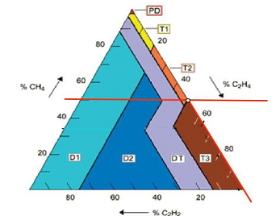
Picture 7. Duval Triangel DGA Test Results

The type of failure recommended by the Duval Triangle Method supports and is similar to Roger's Ratio Method and Key Gas Method analysis, namely the AT04 Power Transformer due to overheating or the effect of high thermal stress.

CONCLUSION
Based on the DGA test with the TRANSPORT X tool which was carried out on October 31, 2018, the following conclusions can be drawn: AT04 Power Transformer Oil is in Condition 1, this means that the transformer is running well because the TDCG concentration value is < 720 ppm. However, when viewed from the high carbon dioxide gas content, it indicates that there is damage to the insulation material. Therefore it is necessary to have further interpretation using other methods. Like the Key gases method, Roger's Ratio, Doernenburg's Ratio and Duval's Triangel method.
The causes of damage to the insulation material in the transformer based on the diagnosis of several methods are: (a) Key Gas Method diagnosing damage to the insulation material due to Overheated Celullose. (b) The Doernenburg Method ratio cannot be used because it does not meet the predetermined conditions. (c) Roger's Ratio Method of diagnosing damage to insulation materials due to Circulating Current in the Winding. (d) IEC Ratio Method to diagnose insulation material damage due to Thermal Fault of Medium Temperature 300o-700oC, and (e) Duval's Triangel Method to diagnose insulation material damage due to Thermal> 700oC.

REFERENCES
[1] Zuhal. (2016). Dasar Teknik Tenaga Listrik dan Elektronika Daya. Jakarta: PT. Gramedia Pustaka Utama.
[2] Muchtar, W. (2017). Dasar-dasar Mesin Listrik. Jakarta: Djambatan.
[3] Sumanto. (2017). Teori Transformator. Yogyakarta: Andi Offset.
[4] Permana, Sumanto, & Saputra. W. S. (2017). “Analysis of Transformer Conditions Using Triangel Duval Method,” Int. Symp. Mater. Electr. Eng., . 384.
[5] Dorf, R. C. (2016). The Electrical Engineering Handbook. Boca Raton: CRC Press.
[6] Faishal A. R, Kartono & Tejo, S. (2018). “Analisis Indikasi Kegagalan Transformator Dengan Metode Dissolved Gas Analysis,” Jurnal Transmisi, 95–102.
[7] Ismono, Haryono, & Suharyanto, (2017). “Metode DGA (Dissolved Gas Analysis) Untuk Perawatan Minyak Transformator Daya di PT. Pembangkitan Jawa Bali Unit Pembangkitan Paiton,” Jurnal Penelitian Teknik Elektro, 125.
[8] Ghonenim, K. A, & Shous. (2015). Diagnostic Tool For Transformer Fault Detection Based on Dossolved Gas Analysis. IOSR Journal of Electrical and Electronic Engineering, 20–26.
[9] Fitzgerald, A. E. (2017). Electric Machinery Sixth Edition. New York: McGraw-Hill Higher Education.
[10] IEEE Std C57. 104. (2016). IEEEGuide for the Interpretation of Gases Generated inoil-Immersed Tranformers. New York.
[11] Rijono, Y. (2016). Dasar Teknik Tenaga Listrik (Edisi Revisi). Yogyakarta: Andi.
[12] Nindiyobudoto & Wahyudi. (2018). Buku Saku Pelayanan Teknik. Depok: Garamond.
[13] Suryatmo, F. (2015). Teknik Listrik Arus Searah. Jakarta: PT. Bumi Aksara.
[14] Tobing, B. L. (2015). Peralatan Tegangan Tinggi. Edisi kedua. Jakarta: Erlangga.
[15] Fitzgerald, A. E., Hingginbotham, D. E., & Grabel, A. (2017). Dasar-Dasar Elektro Teknik. Jilid 2. Jakarta: Erlangga.
[16] Robertson, J. (2016). Keterampilan Teknik Listrik Praktis. Bandung: CV. Yrama Widya.
[17] Singgih, S., & Berahim, H. (2015). “Analisis Pengaruh Keadaan Suhu Terhadap Tegangan Tembus AC dan DC Pada Minyak Trasformator,” Jurnal Teknik Elektro, 1593-3951-1-SM, 93–99.
[18] Simamora, Y., & Tobing, P. (2015). “Analisis Ketidakseimbangan Beban Trasformator Distribusi Untuk Identifikasi Beban Lebih dan Estimasi Rugi-Rugi Pada Jaringan Tegangan Rendah,” Jurnal Singuda Ensikom, 6298-1719-1-PB.
[19] Aslimeri, Genefri, and Z. Hamdi, (2016). Teknik Transmisi Tenaga Listrik Jilid 2. Jakarta: Direktorat pembinaan Sekolah Menengah Kejuruan. Direktorat Jenderal Manajemen Pendidikan Dasar dan Menengah: Deparemen Pendidikan Nasional.
[20] Aslimeri, Ganefri, & Hamdi, Z. (2017). Teknik Transmisi Tenaga Listrik Jilid 1. Jakarta: Direktorat pembinaan Sekolah Menengah Kejuruan. Direktorat Jenderal Manajemen Pendidikan Dasar dan Menengah: Deparemen Pendidikan Nasional.

