MAKING PROTOTYPES OF ELECTRICAL DRYING MACHINES FOR PROCESSED PRODUCTS

Adhan Efendi¹, Oyok Yudiyanto², Ridwan Baharta³
Subang State Polytechnic ^{1,},Bandung Manufacturing of Polytechnic², Lampung State Polytechnic ³
adhan.efendi@gmail.com

Abstract
This research aims to make a drying machine that can help in the food processing. This type of research with research and development. Research data were analyzed descriptively qualitatively. The research was carried out in several stages, namely field observation, literature study, design, manufacturing, and performance testing. The study states that: (1) This drying machine is equipped with a temperature and heat sensor; (2) the manufacturing process of electrical machine dryer was done in three stages: the initial stage, advanced stage, and the final stage. (3) the trial of an electrical dryer machine was used to dry opak, banana and pineapple. Data obtained in the form of opak before drying weighs 3.4 ounces and after drying to 2.2 ounces; the banana before drying weighs 7.3 ounces and after drying to 4.5 ounces;Whereas pineapple before dryer 2.4 ounces and after drying to 1.7 ounces; (4) The result is that the drying machine can dry opaque and processed food faster, usually it takes 5-7 hours to dry, but with this drying machine, opaque can dry with 3-4 hours in temperatures of approximately 120-135 degrees Celsius.

Keywords: electrical dryer machine, processed products, prototypes

Introduction
Indonesia is a country with a tropical climate that has two seasons, namely the dry season and the rainy season. Sun-drying is the most widely used method for agricultural products in many countries [3]. In the rainy season, the people who open businesses in the food processing sector have difficulty predicting uncertain weather. The community needs solar thermal energy to dry food ingredients in the form of opak, tubers, fruits, and others. In the rainy season, it is not often that the value of production has decreased.

Based on the background above, it is necessary to have an electrical dryer machine that can help the community in solving the problem. The presence of this machine is expected to help the community especially those engaged in food or food processing businesses so that in the rainy season the community can still dry semi-finished or raw products to return to the process and the products processed to be more effective.

This research must be carried out because the community experiences obstacles in the process of drying opaque during the rainy season. often communities are required to pursue market targets but are constrained in the drying process. Ditambahkan oleh [1] that the process of making drying machines is needed by the community in Subang.

Drying is among the most ancient and pre-eminent physical methods of food preservation [4]. The drying process is intended to reduce the water content contained in a product to be dried. According to [5], the drying method is selected based on the particular characteristics of the products and socio-economic considerations. Based on the opinion above, it can be concluded that a drying machine is a machine used to reduce the water content in a product to be dried. The dried product is generally in the form of food, fruit, or vegetables. Drying machines have many types depending on their uses, for example, aisle type dryer, cabinet type, electrical, and others. Added by [6], dryers are divided into three types, namely: based on type of food, type of heater, and type of heating technique.

[5] Fruits and vegetables are important sources of essential dietary nutrients such as vitamins, minerals, and fiber. Since the moisture content of fresh fruits and vegetables is more than 80%, they are classified as highly perishable commodities. Added by [7] that damage to fruits and vegetables is caused by high levels of humidity at harvest. Dried vegetables are generally stable after processing and during storage due to low water activity, which is reduced during the drying process to a level that does not support the growth of microorganisms [8].
Fruits and vegetables are seasonal and due to their low shelf life after harvest they are sold in the markets at very low prices. [9] This is due to a large number of crop yields and unprocessed harvests by farmers. [10] Added that one of the preservation of post-harvest vegetables is to use the drying process. Based on the opinion above, it can be concluded that food, fruit, and vegetables are dried and processed into high-selling products. Clarified by [11], keeping the product fresh is the best way to maintain its nutritional value, but most storage techniques require low temperatures, which are difficult to maintain throughout the distribution chain. Foods such as fruit and vegetables have a high water content of more than 80% which makes it very vulnerable to bacteria that cause decay. Dehydration keeps food in a stable and safe condition by reducing water [12].

Autodesk Inventor is a software that is used to design 3D types of Computer Aided Drawing (CAD). In language, manufacturing comes from Latin, namely manus means the hand and factus mean to make. So, manufacturing is the process of making products using hands. Manufacturing is converting raw materials into finished materials as desired by considering aspects of needs, technology, and economics. In the context of this research, manufacturing is intended as a machine manufacturing process starting from the preparation of tools and materials, measurement, cutting of materials, assembly, and finishing.

Method
This research was carried out in the Subang Polytechnic Manufacturing Laboratory. The time needed to carry out this research is 5 months. This type of research with research and development. Research data were analyzed descriptively qualitatively. The stages of this study are field observations, literature studies, design making, machine manufacturing, and performance testing. the research team conducted information on problems in the field, then made an analysis. problem solution is depicted in the form of design, then making a prototype of the machine, testing in the communityResearch plan is shown in figure 1.

Ready
Literature studies
Testing
Yes/No
Finish
Design
Manufacturing

Figure 1. Research Plan

Results and Discussion
Literature Studies
The literature study is carried out by examining various literature books relating to the welding process. Besides, the more important literature study is reviewing international and national scientific journals that have been published. Literature studies are conducted by searching for and analyzing the work of experts.

Design of Electrical Dryer Machine
After the research team collected supporting data, the research team then designed an electrical dryer machine. Machine design uses a 3D inventor application which is then validated by experts. Validation is intended to see the feasibility of the design. added by [2] that making the design will be an important part because the design is the basis for making a prototype of a machine. Dryer design is shown in figure 2.

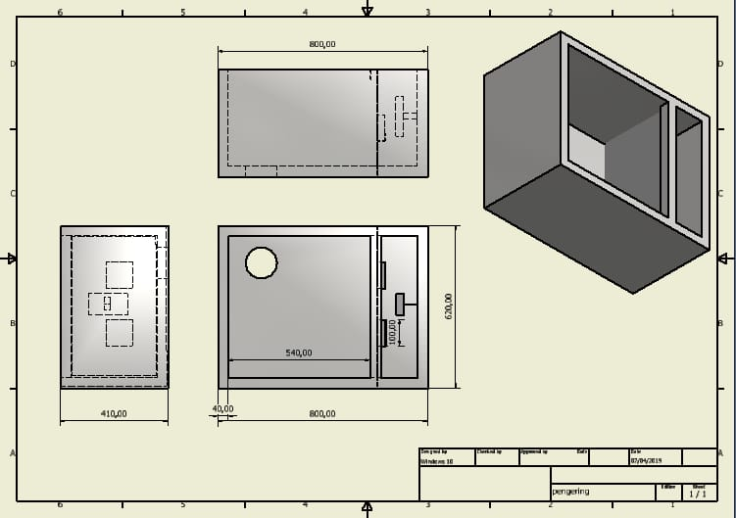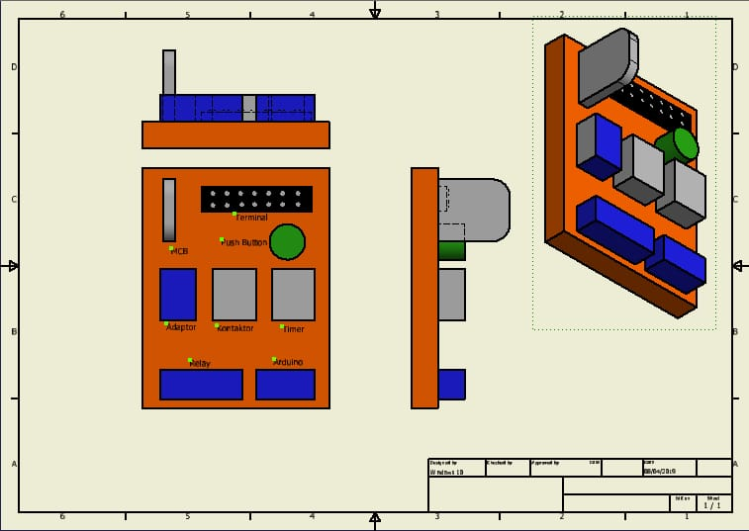
Figure 2. Electrical Dryer Machine Design

Manufacturing of Electrical Dryer Machine
This activity is a follow-up activity after the drying machine design is completed. Some of the main components used to make tunnel dryer machines are: heating components, fans, hollow iron ST37, iron elbows, plates, ram, arduino, etc. The making of the machine is made through three stages, namely initial stage, advanced stage, and final stage of machine manufacturing. It is supported by [12] that in the manufacturing process the standard factor of personal protective equipment (PPE) must be observed following standards to avoid work accidents.

Initial stage of dryer machine manufacturing
Machine manufacturing is following the design made by the design team. Then followed up by the manufacturing team, by making the frame and the outer cover. This initial stage is the main basis in forming a drying machine in order to be able to make the machine according to its function. Initial dryer process is shown in figure 3.

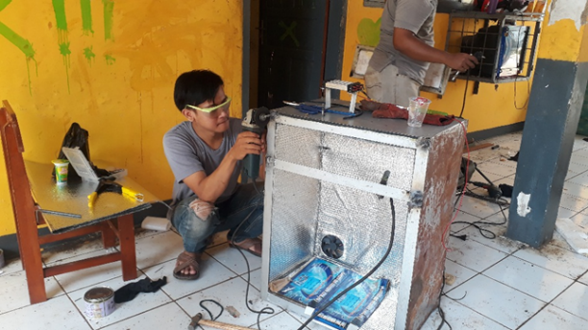
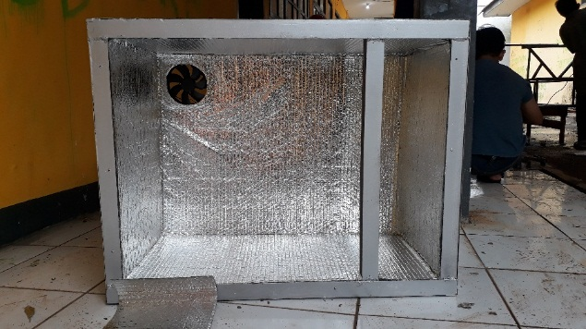
Figure 3. Initial stage of dryer machine manufacturing
Advanced stage of dryer machine manufacturing
Activities in the advanced stage focus on the insulation inside the machine by installing heat shock (Styrofoam, plate and aluminum foil) and installation of the main components of which are in the drying chamber (heating elements, blowers, and sensors). Advanced dryer process is shown in figure 4.
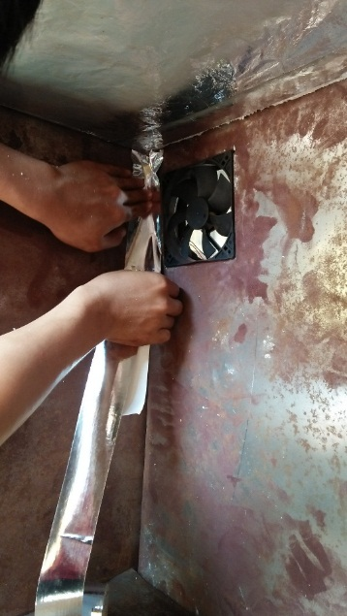

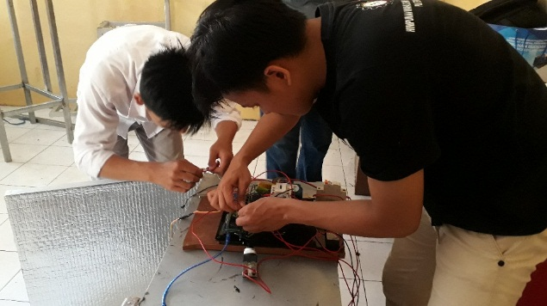
Figure 4. Advanced Stage of Dryer Machine
Final stage of dryer machine manufacturing
The activity at the final stage of the machine which has been done is completed, then followed up by the automation and electricity systems. This activity is in the form of installation of electrical, cabling, and electrical components. The arduino microcontroller automation system sketch was made in the final stages by adjusting construction to improve engine performance. Final stage process is shown in figure 5.

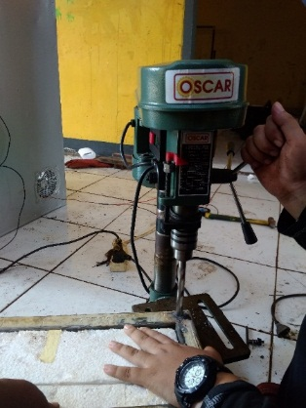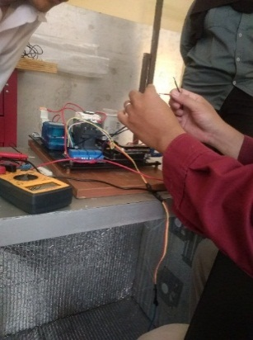
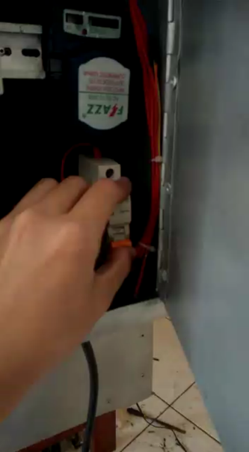
Figure 5. Final Stage Dryer Machine Manufacturing

Electrical Dryer Machine Testing
This activity aims to look at engine performance, engine durability, component durability, product quality, and energy efficiency. The testing phase is carried out using two types of foodstuffs namely opaque and banana. The data obtained in the form of opaque before drying weighs 3.4 ounces and after drying becomes 2.2 ounces. Whereas the banana before drying weighs 7.3 ounces and after drying it becomes 4.5 ounces. The above trial results are also supported by the opinion [7] For all the tomato sizes and at all airflow rate levels, the gram weight of the tomato decreased with an increase in drying time. Also for all sizes at all drying time levels, gram weight decreased with an increase in air flow rate. It is made clear by [3] that the drying tests conducted have shown that the combined drying method seems as well solution suited to the drying of food products, this is a scenario of drying oriented with fixed setpoints (drying air temperature and velocity), that are well-chosen according to the quality of the product to dry. The electrical dryer machine is shown in figure 6.
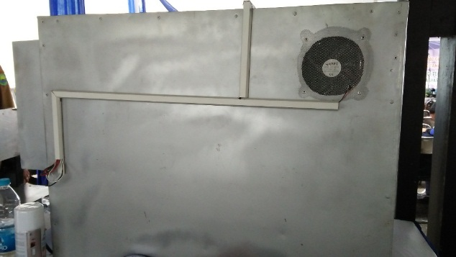
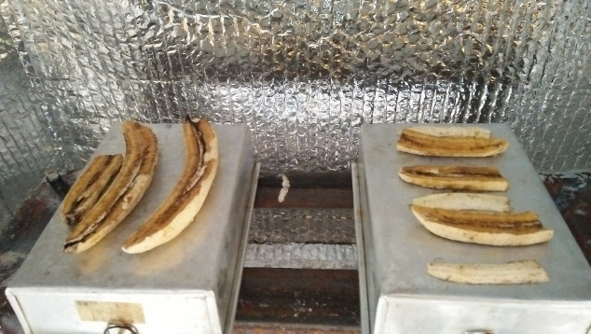
Figure 6. Test Engine Dryer
Work Principle
Figure 7. Work Principle
Heater generates heat from an electric voltage. The heat energy generated is supplied by the drafting room using a blower and the heat energy will be stored in the drying chamber to be used to dry the object. The heat generated by the heater room is used to dry the object by applying hot contact. The water content is released by evaporation. Dampness that is too high due to the evaporation process of the object will be expelled using a blow on the back and will be replaced by new air supplied by pentilation on the front
Engine Specifications
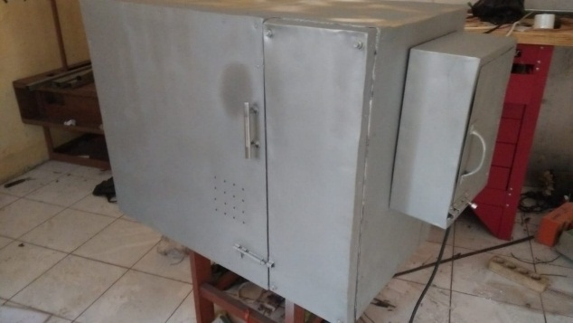
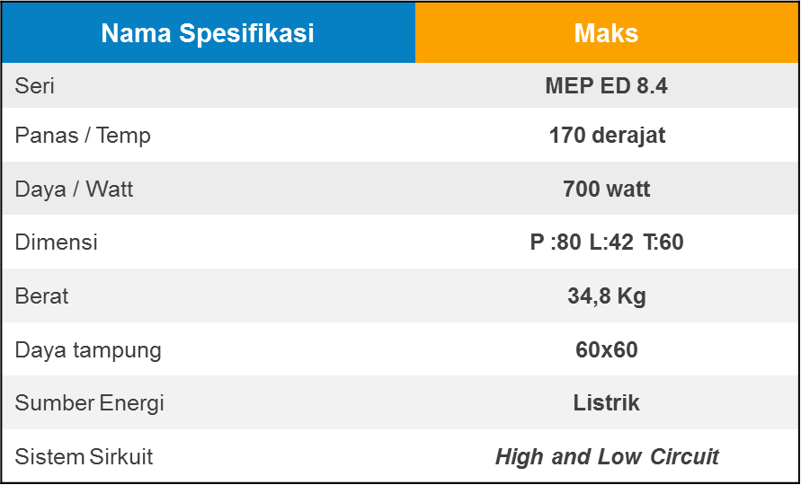
Figure 8. Engine Specifications

Conclusion
The study states that: (1) This drying machine is equipped with a temperature and heat sensor; (2) the manufacturing process of electrical machine dryer was done in three stages: the initial stage, advanced stage, and the final stage. (3) the trial of an electrical dryer machine was used to dry opak, banana and pineapple. Data obtained in the form of opak before drying weighs 3.4 ounces and after drying to 2.2 ounces; the banana before drying weighs 7.3 ounces and after drying to 4.5 ounces;Whereas pineapple before dryer 2.4 ounces and after drying to 1.7 ounces; (4) The result is that the drying machine can dry opaque and processed food faster, usually it takes 5-7 hours to dry, but with this drying machine, opaque can dry with 3-4 hours in temperatures of approximately 120-135 degrees Celsius.

Acknowledgments
Thank you to all the elements involved in making this research, and thanks to the Directorate General of Research and Development Strengthening Overseas Seminar Assistance Program, Kemenristekdikti as funders so that this research can be promoted. This article is the result of a revision of an international seminar at the University of Geoscience, China.

Bibliography
[1] A. Efendi, A. Nugraha, and R. Baharta, “Manufacturing of Electrical Dryer Machine for Food and Fruit Products Manufacturing of Electrical Dryer Machine for Food and Fruit Products,” 2019.

[2] R. dan E. A. Suhartono, “DESAIN MESIN PEMERAH SUSU SAPI PORTABLE MODEL,” vol. 6, no. November, 2019.
[3] H. Oueslati and S. Ben Mabrouk, “Design and Installation of a Solar-Gas Tunnel Dryer,” no. May 2015, 2014.

[4] J. A. Moses, “Novel Drying Techniques for the Food Industry,” no. September, 2014.

[5] V. Changrue and V. G. S. Raghavan, “Stewart Postharvest Review,” no. January 2015, 2006.

[6] Handbook of Industrial Dryer. Taylor & Francis Group,LLC.

[7] J. C. Ehiem, S. V Irtwange, and S. E. Obetta, “Design and Development of An Industrial Fruit and Vegetable Dryer,” vol. 1, no. 2, pp. 44–53, 2009.

[8] S. Mounir, A. S. Mujumdar, B. Bhandari, and Z. Fang, Advances in Drying Science and Technology : Handbook of Drying of Vegetables and Vegetable Products, no. November. 2017.

[9] PR R OJ JE E CT T R RE EP P OR RT T ON DEHYDRATED FRUITS & VEGETABLES (SOLAR DRYER. North Eastern Development Finance Corporation Ltd, 2017.

[10] A. Mohammed, “Design and construction of a Vegetable Drier,” pp. 88–94, 2013.

[11] S. Pragati and B. Preeti, “Technological Revolution in Drying of Fruit and Vegetables,” no. February, 2016

[12] D. Maisnam, P. Rasane, A. Dey, S. Kaur, and C. Sarma, “Recent advances in conventional drying of foods .,” vol. 1, no. 1, 2016.

[13] A. Efendi and D. Komarudin, “Evaluation of the Application of Occupational Safety and Health (OSH) at the Subang State Polytechnic Laboratory,” Automotive Experiences, vol. 2, no. 1, pp. 9–14, 2019.

